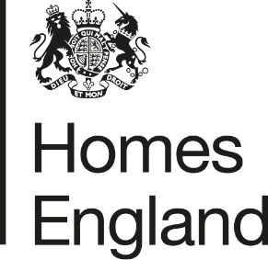
Making homes happen

CITY DEAL EXECUTIVE & STEWARDSHIP BOARD 14th JULY 2020
Homes England Quarterly Monitoring Progress Update Report
Quarter 4 2019 /20
- Report Overview
  - This report provides an update on the progress that has been made in relation to the Homes England sites that form part of the Preston, South Ribble and Lancashire City Deal. The update relates to the progress that has been made during the fourth quarter of 2019/20, between 1st January and 31st March 2020.
  - The report focuses on key delivery milestones, finances invested, and outputs generated, and provides a breakdown of the key risks and any emerging issues across the portfolio of sites.
- Recommendation
  - Homes England recommends that the Executive and Stewardship Board:
Note the content of this report and the progress made by Homes England during the final quarter of 2019/20.
- Homes England Site Highlights
  - Whilst the global pandemic ‘Covid-19’ has had some impact on the financial year end, good progress has continued to be made across Homes England’s sites between 1st January and 31st March 2020. We anticipate that the impacts of the pandemic on the housing market and delivery will be realised throughout 2020/21. Homes England will include an update on these matters in future monitoring reports.
  - Key highlights from the final quarter of 2019 / 20 are set out in the table below:
Phase / Plot | Status | Completions/  Total Units | Completions  (Jan – Mar) | Finance  (Jan – Mar) | Summary
1. Cottam Hall
Phase 1 | Completed by Barratt Homes | 104 / 104 (100%) | Site Completed | n/a | This site has now completed build out.
Phase 2 | Story Homes on-site | 123 / 283 (43%) | 14 | n/a | Story Homes continue to build out site
Phase 3 | Unconditional deal with Morris Homes in place | 0 / 119  (0%) | n/a | n/a | Start on site made Q4 2019. Ongoing issues with newt mitigation have resulted in a delay to delivery, however, show homes have been built and first completions are anticipated Q1 / 2 of 2020.
Phase 4 | Conditional deal with Rowland Homes in place | 0 / 141  (0%) | n/a | n/a | Reserved Matters Application for 141 homes was approved on 11th July 2019. Modification to GCN licence has been approved. Homes England has concluded S106 agreement discussions with third parties. It is hoped that the unconditional stage of the deal will complete Q2 of 2020 / 21, with house building to then commence.
Phase 5 | Site not yet released for disposal | 0 / 233  (0%) | n/a | n/a | Homes England currently determining approach to disposal. Tender to appoint preferred developer partner likely to commence Summer 2020.
Phase 6  (Plots 14 and 15) | Both plots (14 and 15) of Phase 6 have now been disposed of on an unconditional and conditional basis to Countryside and Barratt Homes respectively. | 0 / 189  (0%) | n/a | n/a | The western portion of Phase 6 (Plot 14) was disposed of on an unconditional freehold basis to Countryside. Grant and loan payments made to LCC.  The eastern portion of Phase 6 (Plot 15) was disposed of on a conditional basis to Barratt Homes in Q4. Loan and grant payments are to follow at unconditional deal stage.
2. Cottam Brickworks
Ransom Strip | Homes England re-commenced negotiations with the landowner’s agent (BXB) and LCC for past 12 months | 0 / 260  (0%) | n/a | n/a | Further liaisons between Homes England, LCC and the landowner’s have been held and discussions are ongoing to find a resolution to the sites access rights.
3. Land at Eastway
Residential Plot | Story Homes on-site completing build out | 110 / 329  (33%) | 7 | n/a | Story Homes continues to build out, with 7 completions during this reporting period.
Commercial Plot | Site under conditional contract with HSB Healthcare | n/a | n/a | n/a | Homes England acquired community registered asset (CRA) land within the vicinity of the site in February 2020. Delivery of a new access into the site is yet to commence, estimated to be June / July 2020.
4. Whittingham Hospital
Phase 1 | Taylor Wimpey has completed Phase 1 | 150 / 150 (100%) | n/a | n/a | Taylor Wimpey has completed build out of Phase 1.
Phase 2 | Preferred bidder Barratt David Wilson selected end of March 2020. | 0 / 232  (0%) | n/a | n/a | Preferred bidder Barratt David Wilson selected at the end of March 2020 and conditional contract agreed. Reserved matters to be submitted during the next financial year reporting period.
Phases 3 and 4 | Not yet released. Disposal phases and options to be reviewed in 2020 / 21. | n/a | n/a | n/a | Current strategy is to dispose of part of the next phases (circa 40 units) in 20/21 however this to be confirmed dependant on market interest.
5. Preston East
Expansion Area | In Q4 Homes England submitted a representation to the Central Lancashire Local Plan review supporting further allocation of the site. | n/a | n/a | n/a | Homes England has submitted a Development Statement to promote the site for continued allocation within the Central Lancashire Local Plan. The site is currently being marketed.
Sector D | Deal completed with Inchcape Estates now on site | n/a | n/a | n/a | Inchcape Estates continue development of site with construction underway.
6. Pickerings Farm
n/a | Masterplan and outline application submitted | 0 / 345  (0%) | n/a | n/a | Masterplan and outline application currently being considered and detailed dialogue with SRBC and LCC is taking place. Further due diligence is also underway to support the planning application.
7. Altcar Lane
n/a | Continued build-out | 25 / 200  (13) | 4 | n/a | Lovell continue to build out the site
8. Croston Road North
n/a | Preferred Bidder (Keepmoat) approved October 2019 | 0 / 400  (0%) | n/a | n/a | Agreement for lease entered into with Keepmoat subject to planning. Anticipated to go unconditional upon receipt of planning permission currently estimated November 2020.
9. Croston Road South
Phase 1 | Miller Homes has completed Phase 1 | 96 / 96 (100%) | 19 | n/a | Miller Homes has completed Phase 1
Phase 2 | Miller Homes on-site | 68 / 79  (86%) | 6 | n/a | 6 completions have been recorded on Phase 2 of this site during this period.
10. Brindle Road
n/a | Complete | 46 / 46  (100%) | n/a | n/a | All units completed and all finances paid.
11. Walton Park Link
n/a | Morris on site | 17 / 275  (6%) | 17 | n/a | Morris commenced early site clearance works on site in September. Remediation work and construction of link road, with first housing completions delivered.
- Finance
  - Homes England is currently still on track to pay the majority of £37.5 million grant by 2023 / 24 however this position has been reviewed as part of the Homes England Business Disposal Plans (BDP) Refresh (2020/21-2023/24) and some grant will now be paid up to 2030 in relation to the contract with Keepmoat at Croston Road North, this will be detailed in the BDP and presented to the Board.
  - A grant payment of £429,673.37 and loan payment of £1,153,116.63 were made to LCC during Q4 of 2019/20 in relation to the unconditional disposal of Cottam Hall Phase 6 (Plot 14) to Countryside.
  - The following payments are anticipated to be made in the next financial year (2020/21):
    - A loan amount of £123,497.00 is expected to be paid out in Q2 of 2020 (estimated July) in relation to the sale of the Local Centre site at Cottam Hall
    - A loan amount of £1,217,707.00 is currently anticipated to be paid out in Q3 of 2020 (estimated November) subject to reserved matters consent being achieved and agreement with Keepmoat going unconditional on Croston Road North
    - A loan amount of £2,578,006.00 is also expected to be paid out within the latter period of 2020/21 in relation to Phase 4 (Plots 1-3) of Cottam Hall and
    - Grant payments totalling c£3.5m are forecast to be paid in relation to development at the Eastway site later in 2020/21.
- Summary of Delivery
  - Good progress has been made on site delivery across Homes England’s portfolio during the final quarter (Q4) of 2019/20, with a grant and loan payment made to LCC as detailed above.
  - The key delivery milestones for quarter 4 included:
    - Selection of a preferred developer (BDW) on Plot 15 at Cottam Hall with the conditional contract agreed
    - Outline planning consent achieved at Whittingham Hospital, subject to a Section 106 agreement
    - Selection of preferred developer (Keepmoat) at Croston Road North with the conditional contract agreed
    - Submission of an outline application on Pickering’s Farm and
    - Selection of a preferred developer (BDW) for Whittingham Hospital Phase 2 with the conditional contract agreed.

Summary of BDP Payments |  |  |  | BDP Forecast 2019 / 20
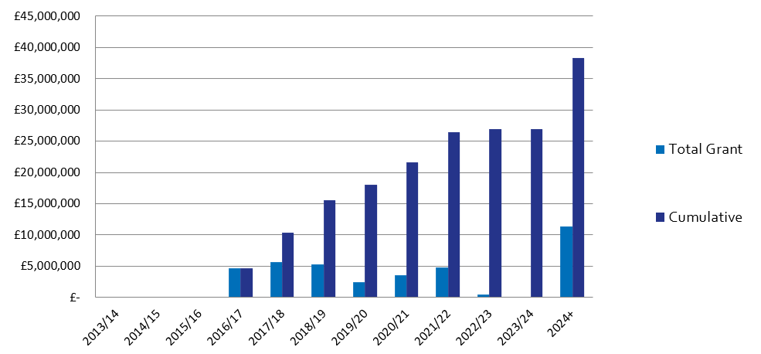
 |  |  |  |  | Q1 | Q2 | Q3 | Q4 |  | In Year Actual | BDP forecast for 20 / 21
 |  |  |  | Grant | £0 | £2m | £0 | £429,673 |  | £2,429,673 | £3.6m
 |  |  |  | Loan | £0 | £0 | £0 | £1,153,117 |  | £1,153,117 | £5.5m
 |  |  |  | Housing Completions | 33 | 57 | 74 | 67 |  | 231 | n/a
Planning Consents |  | Starts on Site |  | Housing Completions |  |  |  |  | Grant Payments
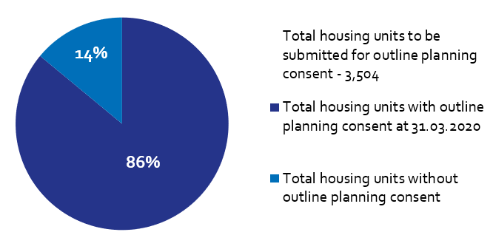 |  | 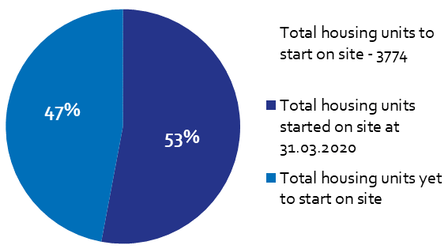 |  | 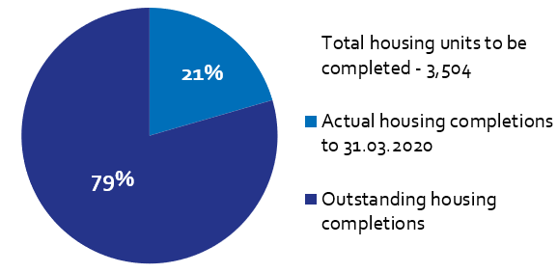 |  |  |  |  | 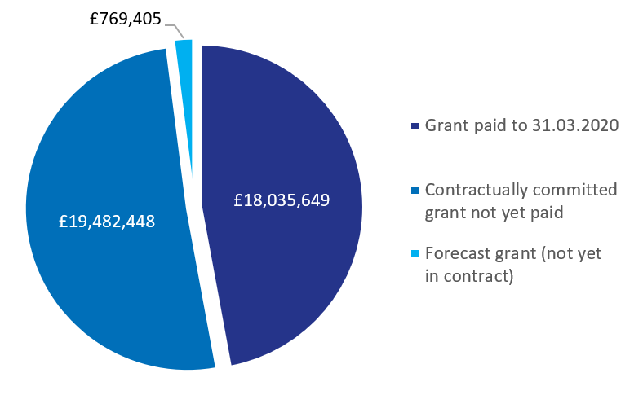
Of the Homes England residential City Deal sites, only Pickering’s Farm is yet to achieve planning consent.  An outline application was submitted this quarter. |  | Housing starts have been claimed for 1,678 units on Homes England City Deal sites to date.  Starts are claimed in full upon commencement of the site. |  | There have been 719 housing completions to date on Homes England City Deal sites.  There were 67 housing completions during this reporting period. |  |  |  |  | To date, £18,035,649 has been paid to LCC as grant, with a further £19.4m contractually committed across Homes England City Deal sites.

